
Supplement to
Specifications for Electrical Installations
2022

Covering PPL’s Service Areas
in Rhode Island (RI)
Underground Residential Distribution (URD)
Installation and Responsibility Guide
Electric Service Bulletin 759A

Table of Contents
1.0 Scope 3
2.0 General Requirements 3
3.0 Type of Service 3
4.0 Plans 4
5.0 Permits 4
6.0 Division of Responsibility 5
7.0 Easements 6
8.0 Trench Construction Requirements 6
9.0 Trench and Conduit System Inspection 7
10.0 Conduit Installation 8
11.0 Future Use 9
12.0 Transformer Box Pad Installation 9
13.0 Transformer Secondary 10
14.0 Transformer Grounding and Bonding 10
15.0 Spacing of Boxpads, Pullboxes, and Handholes 10
16.0 Proper Transformer Pad and Conduit Layout 11
17.0 Transformer Ground Grid Bonding 13
18.0 Proper Transformer Pad and Conduit Installations 15
19.0 Transformer Oil Containment 19
20.0 Riser Pole 22
21.0 Primary Cable Pull/Splice Box 24
22.0 Trench Requirements 26
23.0 Conduit Requirements 28
24.0 Metering 29
25.0 Easement Applications 30
26.0 Approved Material – Underground Residential Installations 32
27.0 Job Checklists 35

URD Specifications and Installation Guide Acknowledgement (Job Spec/Signoff Forms)
The requirements and specifications outlined in this guide book must be strictly followed. Any requirements not adhered to can pose safety problems, can be detrimental to the installed system and must be corrected before final acceptance. The Customer will bear full cost to make corrections to sub-standard installations.

The Customer is responsible to provide enough lead time for the Company to design job, provide inspections and install Company equipment where applicable.

Typical lead times are shown below.

 | Lead-Time | Notes
Design and Layout | Eight weeks | Company receives all required plans, load data and easement information
Trench, Conduit and Equipment Inspection | Three days | Company inspector
Company Installation | Four weeks | After all inspections are approved and permits/ easements are procured
NOTE: The above times are estimates only.

Project Title

Location

Owner/Developer

Customer’s Representative Date

Company Representative Date

Company’s Copy

URD Specifications and Installation Guide Acknowledgement (Job Spec/Signoff Forms)
The requirements and specifications outlined in this guide book must be strictly followed. Any requirements not adhered to can pose safety problems, can be detrimental to the installed system and must be corrected before final acceptance. The Customer will bear full cost to make corrections to sub-standard installations.

The Customer is responsible to provide enough lead time for the Company to design job, provide inspections and install Company equipment where applicable.

Typical lead times are shown below.

 | Lead-Time | Notes
Design and Layout | Eight weeks | Company receives all required plans, load data and easement information
Trench, Conduit and Equipment Inspection | Three days | Company inspector
Company Installation | Four weeks | After all inspections are approved and permits/ easements are procured
NOTE: The above times are estimates only.

Project Title

Location

Owner/Developer

Customer’s Representative Date

Company Representative Date

Customer’s Copy

1.0 Scope
The purpose of this specification is to define, interpret and clarify the scope of work and material dealing with providing service to URD’s and is a Supplement to Electrical System Bulletin (ESB) 750.

It is important that the Specifications for Electrical Installations book (ESB 750) be obtained and referred to in conjunction with this supplement for these installations. Any reference to the Company in this specification shall mean Rhode Island Energy. Any reference to the Customer or Developer in this specification shall mean the property owner or the designee of the property owner of the URD.

2.0 General Requirements
All electrical wiring to be connected to the Company equipment shall be installed in accordance with one or all of the following:
Local Municipal Inspection Authority State’s Electrical Code
National Electrical Code National Electrical Safety Code
Applicable Distribution Construction Standards of the Company
RIE’s Specifications for Electrical Installations

There shall be no attempt to deviate from either the Distribution Standards of the Company or the Company construction plan without the approval of the Company. Any specifications noted shall supersede the Specifications for Electrical Installations booklet unless otherwise approved by the Company.

It is mandatory that the Customer and all parties involved attend a documented pre-construction meeting with a Company representative to discuss the project and ensure it a timely completion.
A Company representative will make the necessary arrangements for the pre-construction meeting. Company representatives will also be available throughout the job life cycle to discuss construction problems when requested or during a field visit.

References:
ESB 750 - Specifications for Electrical Installations
ESB 754 - Outdoor Padmounted or Vault Enclosed Three Phase Transformer

The Customer shall be responsible to have all electrical and physical design documents prepared and updated by a design professional, in accordance with Section 1.7 of ESB 750 for the trenching, conduit, transformer pad, and handhole installations.

3.0 Type of Service
Electric service shall be single phase, three wire, 120/240V supplied from a padmount transformer or handhole to be located on the Customer’s premises. The primary electrical service to the URD will be supplied from a pole or cable system owned by the Company.

4.0 Plans
When municipal approval is required, the Company shall receive final town approved development plans on a scale not less than one inch equal to one hundred feet in both hard copy and CAD format prior to engineering construction plans. Information regarding the total number of houses to be built in subdivision, and whether the development will be installed in phases shall also be provided. The property site plan shall show all proposed and existing overhead and underground utilities, i.e. electric, water, gas, sewer, cable television, telephone, etc.
A copy of a street light proposal must also be provided for the development, approved by the municipality, or written notice from the municipality that street lighting will not be required. If installation is requested after construction is complete, additional costs, including the Company’s tax liabilities, may be borne by the municipality and/or Customer if the tariff does not collect all costs of construction.
Direct Burial Systems in general: the Company specifies an arrangement whereby the Company’s power cables may run parallel with communication and other power cables, but not parallel with other utilities e.g. water, gas, sewer. These utilities shall be in a separate trench. The other utilities must maintain clearances as outlined in the NESC or by mutual agreement. RIE gas is permitted in the same trench with the following requirements: gas shall be at a minimum depth of 18” and shall maintain a minimum separation of 12” between all other utilities.
Conduit Systems in general: the Company requires a spare conduit for all Company owned duct systems, as shown in Company plans. Other utilities must maintain clearances as outlined in the NESC.

5.0 Permits
In general, all applicable permits necessary to trench and excavate, including street openings and environmental permits, shall be obtained by the Customer and made available upon request of Company prior to design. The Customer shall be responsible for including these padmount and conduit/trench specifications with the wetlands application for developments located in or near wetlands. A copy of the wetlands permit may be requested by the Company prior to acceptance of the conduit/trench system by the Company.
The Customer/Company doing the excavation shall obtain the required DIGSAFE permits before any excavation may take place in a public way. The Customer/Company doing the excavation is urged to obtain copies of the applicable statute and become familiar with its requirements. Similarly, the Customer/Company shall determine if the municipality in which the excavation is to be done requires that water, sewer or other utility, municipal or private, be contacted separately due to the possibility they may not be members of DigSafe® The Customer is also responsible to notify the company of all as-built changes that may conflict with design).
The Customer shall certify to the Company that areas in which the Company is to perform installation or maintenance work is free of preexisting contamination by hazardous wastes or materials and to indemnify the Company for any claims, costs, expensed, suits, demands, citations, fines or damages of any kind arising from the presence of any such contamination.

6.0 Division of Responsibility
The division of ownership and responsibility shall be as outlined below by state. Typical installation specifications to reflect installation practices are shown in the back of this guide.
    - The Company will:
      - Develop the plan to provide underground electric service,
      - Supply a list of approved manufacturers and their part numbers for equipment to be supplied by the Customer, (See Pages 39-41)
      - Designate the location of all Company owned equipment,
      - Provide Company owned street light foundations and any cable-in- conduit required for street light applications,
      - Provide, install, own and maintain all transformers, Company owned street lights, primary and secondary cable, except services,
      - Make all connections to Company equipment,
      - Inspect the underground conduit system and equipment foundations installed by the Customer,
      - Determine if oil containment shall be required for padmount transformer installation.
    - The Customer, at no cost to the Company, will:
      - Provide, prior to the start of the Company’s construction, all applicable documents required for the Company to prepare easements for its facilities to be installed on private property,
      - Install foundations and cable-in-conduit, provided by the Company, for
Company owned street lights;
      - Provide and install all other required handholes, box pads, splice boxes, grounding systems, and conduit including spacers, galvanized conduit and sweep for riser pole including bonding clamps and neutral tap, glue and pulling tape, marking tape, etc. as indicated on the Company’s plan and related construction documents,
      - Supply copies of all invoices, when requested, indicating manufacturer and part number for all such equipment listed above; equipment that is not approved shall not be used without the prior written consent of the Company,
      - Install, own and maintain all secondary services and service conduit from the Company’s equipment to each designated meter location,
      - Turn over ownership of the conduit system, excluding the service conduit, to the Company upon inspection and acceptance of the conduit system by the Company,
      - Provide and install material for oil containment under padmounted transformers where required.

7.0 Easements
In general, Company-owned equipment shall not be installed on the Customer’s property prior to the execution of suitable easement(s). The Customer will have to provide to the Company (for the purposes of securing an easement) the following items, including but not limited to:
Copy of property deed showing: owner, date, book number, page number county registry, and survey and/or plan of record, if available.
Note: When electronic maps are used, the Customer must consult the Company for submittal. Copy of mortgages showing: holder, date, book number, page number and county registry.
Copy of any applicable trusts showing: date, book number, page number and county registry, and who is authorized to sign legal documents on behalf of the Trust.
Easement application forms are located on Page 35. Refer to Sections 3.1.3 and 4.1.1 in ESB 750 for further easement requirements applicable to the Applicant or Customer.

8.0 Trench Construction Requirements
    - Layout and Grading
      - Final grades shall be established and the binder coat installed, and easement boundaries, street, lot and trench lines staked by the Customer before any trenching is started (except for Company inspected road crossings).
    - Trenching and Backfilling
      - The Customer shall adhere to the construction plan specifying trench locations and depths, with any deviation being subject to approval by the Company.
      - Minimum burial depths specified for all electrical conduit and direct burial trenches shall be maintained during all phases of construction. Temporary mechanical protection over buried conduit during construction to prevent conduit crushing or damage due to unusually heavy construction equipment shall be the responsibility of the Customer.
      - Trench detail shown in attached Company Standards shall be adhered to. The trench bottom shall be solid, undisturbed earth. Earth showing signs of peat, cinders, rubble or any conditions not suitable for a stable foundation shall be reported to the Company Representative for recommendation. Pockets of unsuitable soil shall be replaced with compacted sand.
      - For work done by Customer, a Company representative shall be notified in advance of the backfilling of any electric facility, i.e., conduit, foundation, handhold, pull-box, cable-in-conduit, grounding, cables, etc.
If any facility is backfilled without the Company’s prior approval, the Company reserves the right to require re-excavation of the facility.
aa. Sand for conduit installation - A minimum of three inches of sand shall be placed, under, beside, around and on top of all electric conduit. The sand shall pass through 3/8 inch mesh screen and shall not contain any sharp stones. Sand shall be placed and suitably tamped over installed conduit in reasonably small quantities (not a front end loader bucketful all at once) to avoid conduit damage. Sand shall be evenly distributed between and around all electric conduits.
bb. Sand for direct burial installation - A minimum of two inches of sand shall be placed at the base for the cables to be installed on top of. A minimum cover of four inches of sand be placed on top of the cables. The sand shall pass through 3/8 inch mesh screen and shall not contain any sharp stones.
Sand shall be placed and suitably tamped over installed cable in reasonably small quantities (not a front end loader bucketful all at once) to maintain minimum cover. Sand shall be evenly distributed between and around all electric cables.
      - Remainder of backfill shall not contain stones greater than once inch and shall not contain ashes, cinders, shell, or frozen material,
      - Trenches shall be immediately backfilled following cable or conduit system inspection and approval by authorized Company representative,
      - Backfilling shall be accomplished in a continuous manner from one terminal, i.e., riser pole, foundation, handhold, etc. to the next,
      - Backfilling shall not take place over any open-ended (unplugged) conduits,
      - Company approved red cable “Warning” or “Marking” tape shall be installed in the trench 12 inches below finished grade and directly above the cable or conduit.

9.0 Trench and Conduit System Inspection
In the applicable area, a designated Company inspector shall be responsible for the inspection of the trench and/or conduit system being prepared and installed by the Customer at various stages of installation. The Customer shall provide the Company inspector with a minimum of 24 to 72 hours notice.
Inspections shall be conducted:
    - After conduit, ground system are completed; but before concrete is poured
    - After concrete is poured, but before backfilling if applicable
    - After backfilling
The inspection shall include, but not be limited to the following:
- All trenches and excavations
- All material supplied by the Customer
- All backfill and base sand material during or after installation as applicable
- All foundations, pull-boxes, boxpads, handholes, and other facilities, after setting in place, but prior to backfilling
- All galvanized steel riser pole and sweep conduit installations, all conduit, including cemented joint, bends, sweeps, bell-ends, and conduit spacers, prior to backfilling, or concrete encasement
- All conduit terminations and supports at boxpads, pull-boxes, handholes, riser poles, streetlight foundations, and at other applicable locations
- The pouring of any required concrete encasement and subsequent backfilling around the conduit runs
- All backfilling operations
- Witnessing mandrelling of all conduits

10.0 Conduit Installation
    - Conduit shall be installed in accordance with Standards and Construction Plans which accompany this specification package.
    - Plastic spacers shall be used to separate all duct where more than one duct is installed. Spacers shall not exceed eight foot intervals. Spacers shall be placed at each coupling. Spacers are required to maintain proper separation from adjacent conduits and to aid in proper sand placement for thermal reasons.
    - Type DB conduit shall be employed whether duct is direct buried or encased in concrete.
    - All galvanized steel sweeps at risers shall have a minimum radius of 36 inches. 48 inch radius sweeps are required at transformer foundations and secondary handholes. See Page 17 for details.
    - Curves and bends in conduit runs shall be gradual, and the radius of curvature shall not be less than 40 feet. Only five Degree Angled Couplings shall be used to make these gradual bends.
    - Conduit grade shall be such as to cause all ducts to drain toward one or both equipment foundations, pullboxes or handholes. Minimum pitch shall be three inches per 100 feet. Pullboxes may be required near riser pole if grade at pole is low compared to the first boxpad to alleviate water buildup in riser.
    - Conduit shall have a maximum penetration inside walls of pull/splice boxes, equipment foundations or handholes of three inches. All unused conduits and conduit knockouts shall be sealed with conduit plugs. Bell ends shall be installed at the end of all conduit runs.
    - The minimum separation between electrical conduit and foreign conduit or pipes shall be as follows:
- Communication systems – 12 inches
- Water, Gas and Sewer – 12 inches where the paths of these utilities intersect electrical conduits at approximately right angles. A minimum separation of 24 inches shall be maintained between parallel placement of any of these utilities and electrical conduits.
- All road crossings shall, when practical, be perpendicular to the sidelines of the road.
- All road crossings shall have 30 inch minimum burial depth, top of conduit to finished grade, for primary and 24 inch minimum for secondary voltages. (including street lighting cable-in-conduit) Main electric trench shall maintain conduit depths as shown in on Page 32.
- Where foreign objects threaten to interfere with the installation of conduit in the sidewalk area or other areas, the Company may require concrete encasement of the conduit.

11.0 Future Use

This section intentionally left blank.

12.0 Transformer Box Pad Installation
- All foundations shall be level and installed in accordance with drawing on Pages 16-17.
- A minimum of four inches base course of crushed stone (3/4 in maximum stone size) shall be placed under all transformer foundation excavations and thoroughly compacted using a vibratory compactor. Certain soil conditions may require removal below normal depth and subsequent additional clean sand or stone added and compacted to insure sound base course for foundation. For direct burial cable installation, cables are to be surrounded by at least 4” of sand at base area crossing from the trench into the box pad.
- Transformer foundation top surfaces shall be four inches above final grade. In no instance shall final grades hamper proper access or operation of equipment.
- A buried ground grid shall be installed in accordance with details shown on Pages 18 and 19. Ground loop around transformer to be buried 12” below finish grade (not at foundation base depth). Telephone Company bond wires shall be tied to the ground grid. Such bonding or connection shall not interfere with connecting Company equipment.
- Retaining walls or other devices shall be installed where slopes exist that would undermine or cover equipment, such as transformers due to sharp drop-off or rise.

NOTE: In most instances, the Company shall require that equipment easements on private property be reasonably level. Also, all retaining walls shall fall outside of equipment easements and in no case shall they hamper door openings or placement of such equipment. Retaining wall design shall be approved by the Company.

- Upon completing the installation of the transformer foundation, the top opening shall be securely sealed with a suitable matching cover.
- Transformer foundation shall be completely backfilled prior to commencing any cable pulling.
In some locations oil containment may be required for box pad installation, Pages 24 and 25 show installation procedure.

13.0 Transformer Secondary
Customer secondary service wires entering the box pad shall be in accordance with the NEC and shall be approved by the wire inspector or AHJ (Authority Having Jurisdiction) of the town or city involved. Maximum size of secondary cable to be physically connected to the Company's pad-mounted transformer is 500 kcmil. No more than six secondary services shall be connected at any Company supply point. Cables shall be left with five feet of slack coiled inside the pad in order to reach to the secondary connection points on the transformer.

14.0 Transformer Grounding and Bonding
The ground grid shall be number 2, bare, soft drawn, seven strand copper wire. The wire shall be installed 12 inches below finished grade and located around the transformer pad as shown on Page 18. Bond to all exposed metallic conduit and leave three feet of wire above pad for grounding transformer.
Two ⅝ inch diameter, eight feet long copper weld ground rods and approved connectors shall be installed to 12” below finished grade. Leave the ground rods and grid exposed until inspected by the Company. The ground grid is to be complete and backfilled prior to energizing the transformer. Connections to ground grid to be made with compression connectors as shown on Pages 18 and 19. However exothermic welding ("cad weld") shall be an acceptable alternative to a compression connection. Bolted connectors are only acceptable for the ground grid connections to the ground rods. The Company shall install the ground taps onto the transformer.

15.0 Spacing of Boxpads, Pullboxes, and Handholes
All communication boxes shall be a minimum of 2’ away from any Company boxpad, pullbox or handhole. Also, communication equipment shall not be placed in front of any Company equipment.

16.0 Proper Transformer Pad and Conduit Layout
Figure 16.0-1 Preferred Location of Equipment in Easement Area
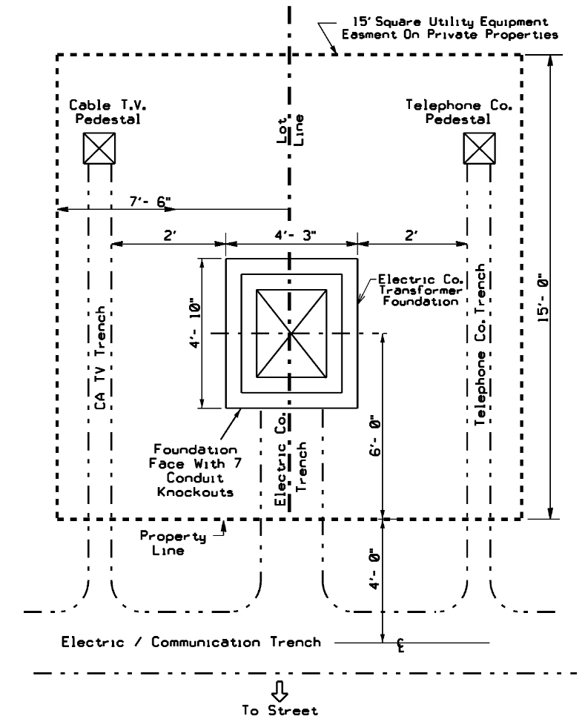

Figure 16.0-2 Single Phase Padmount Transformer — Typical Layout
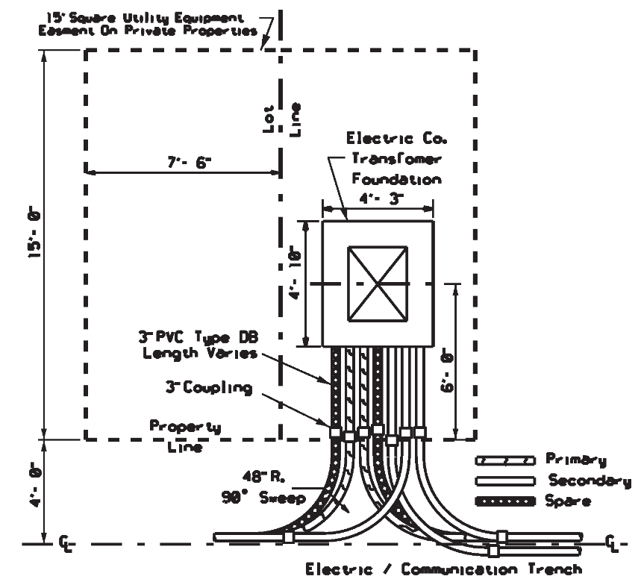

16.0-3 Single Phase Padmount Transformer — Direct Burial Layout
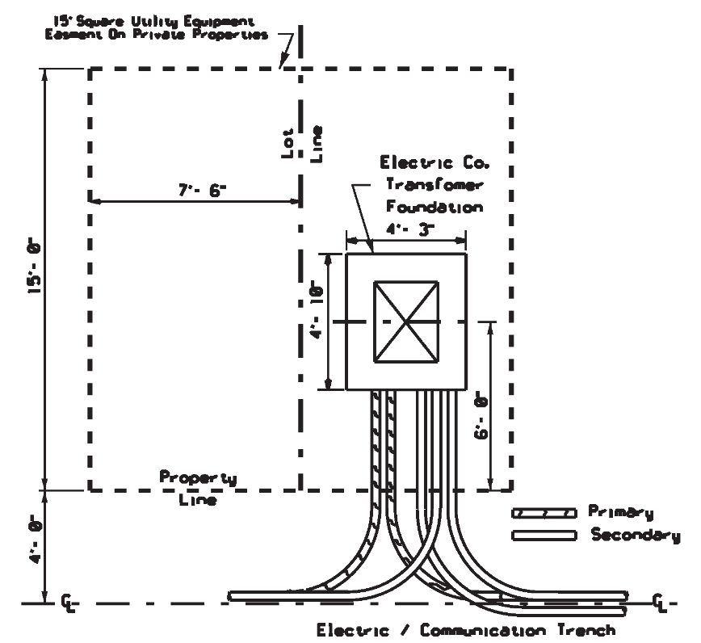
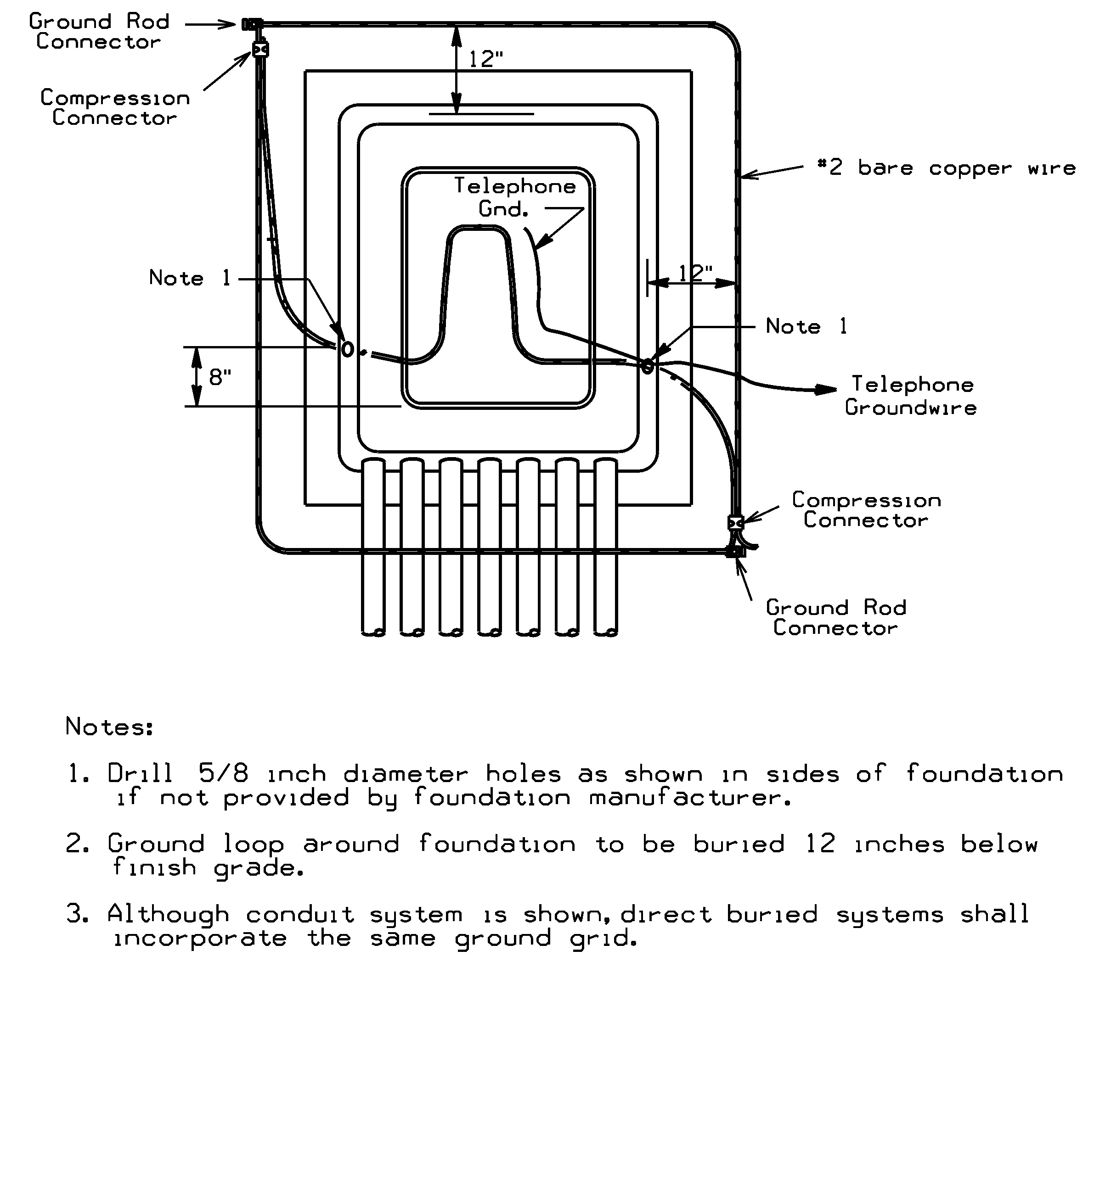

17.0 Transformer Ground Grid Bonding

Figure 17.0-1 Single Phase Padmount Transformer Ground Grid

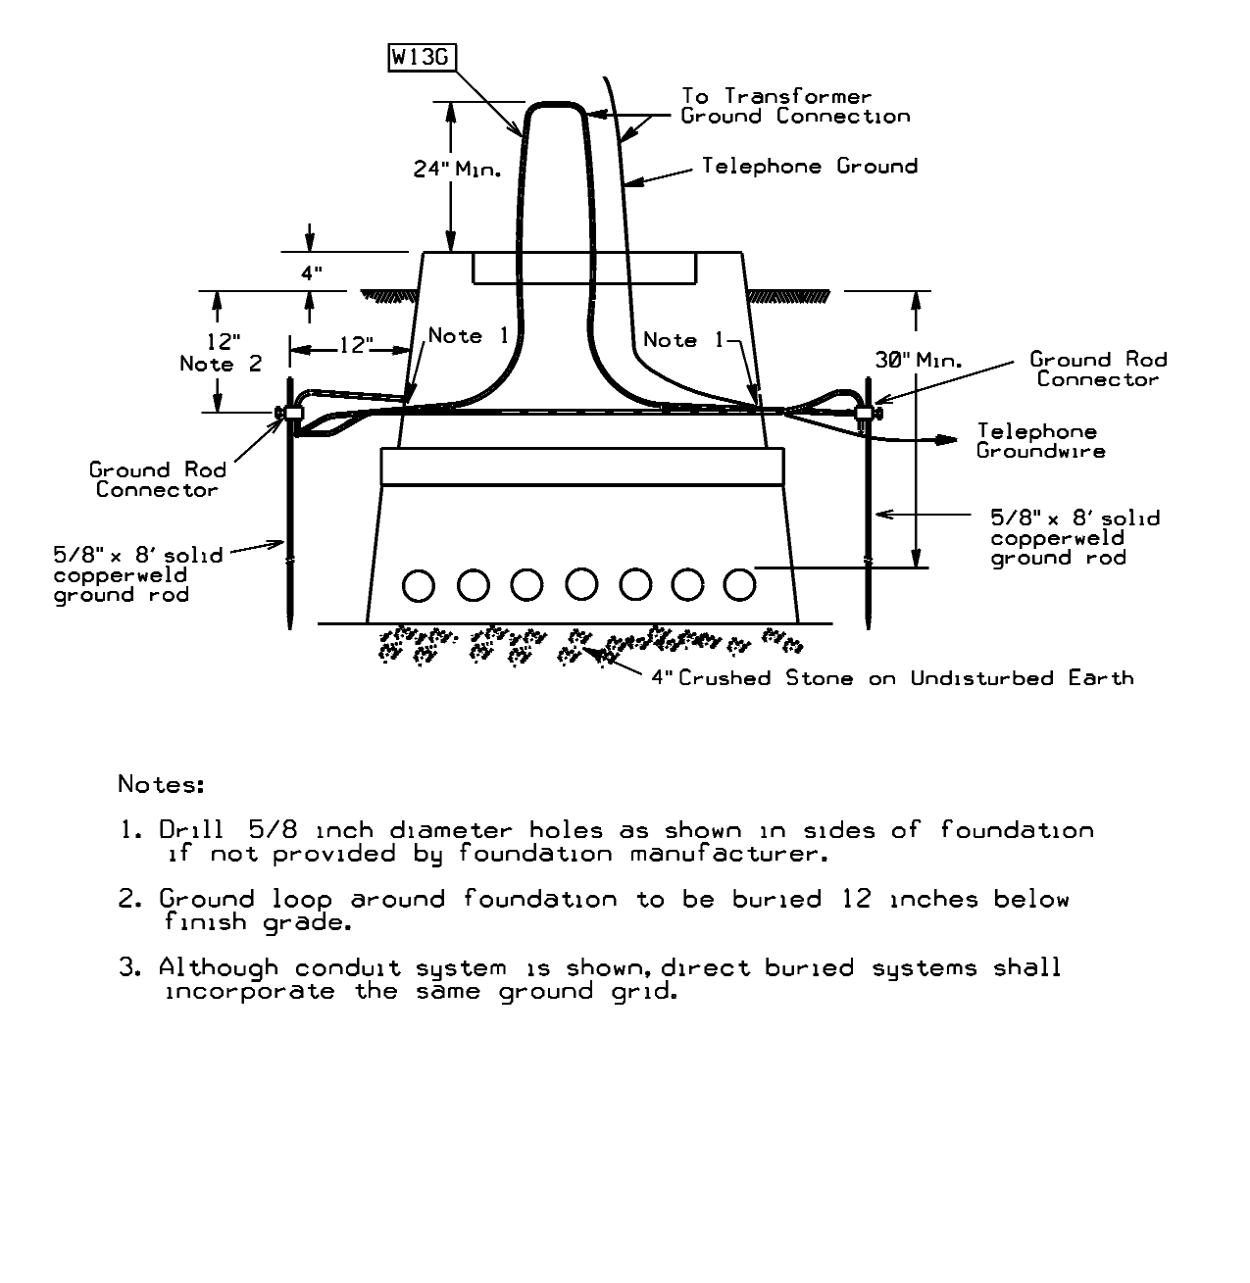
Figure 17.0-2 Single Phase Padmount Transformer Ground Grid — Front Elevation

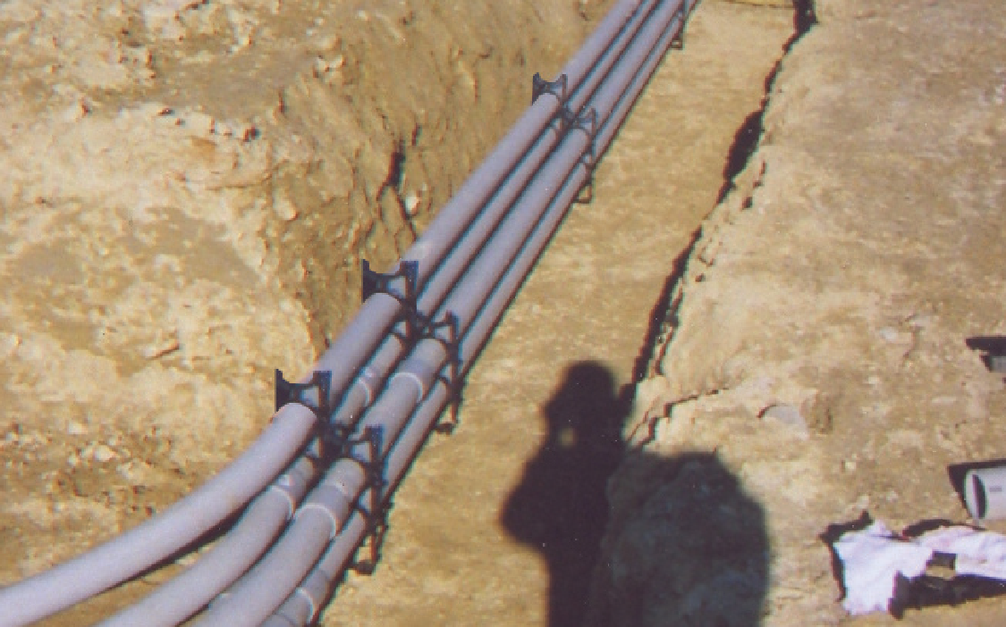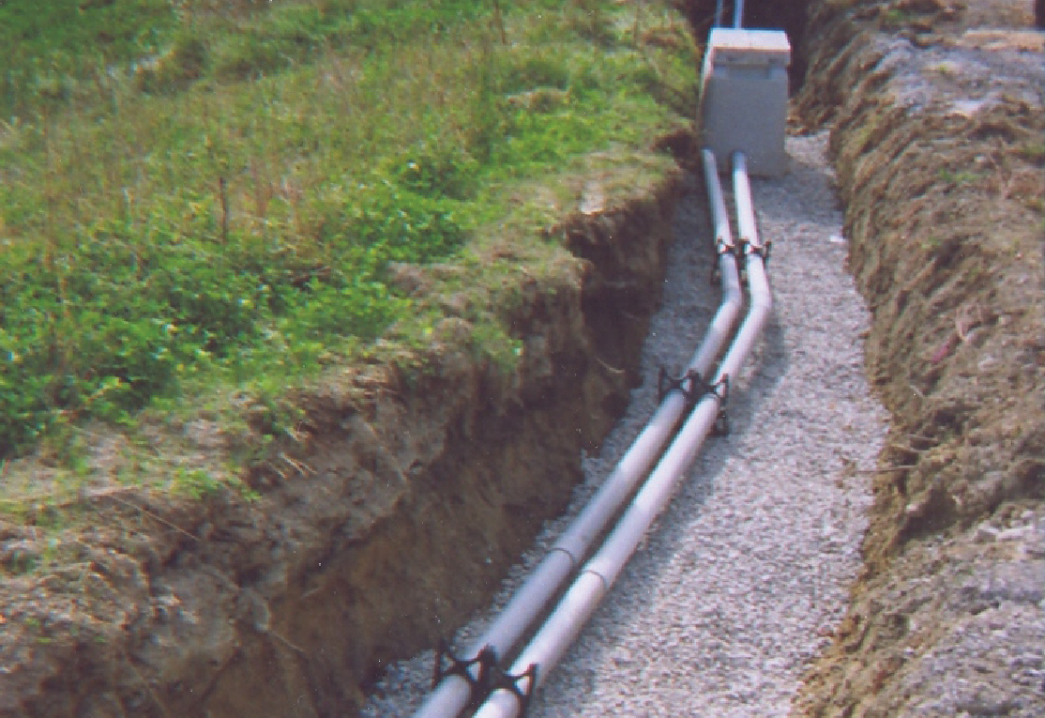

18.0 Proper Transformer Pad and Conduit Installations

18.0-1 Proper Conduit Bank Installation (Pre-Backfill)

18.0-2 Proper Installation of Conduit with Pullbox used for Drainage (Pre-backfill)

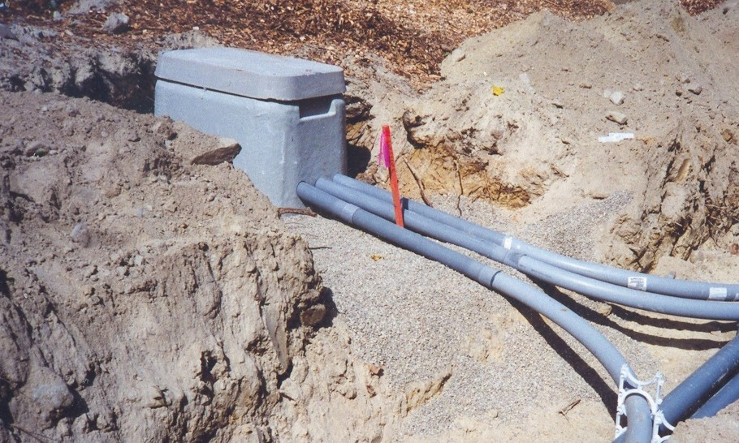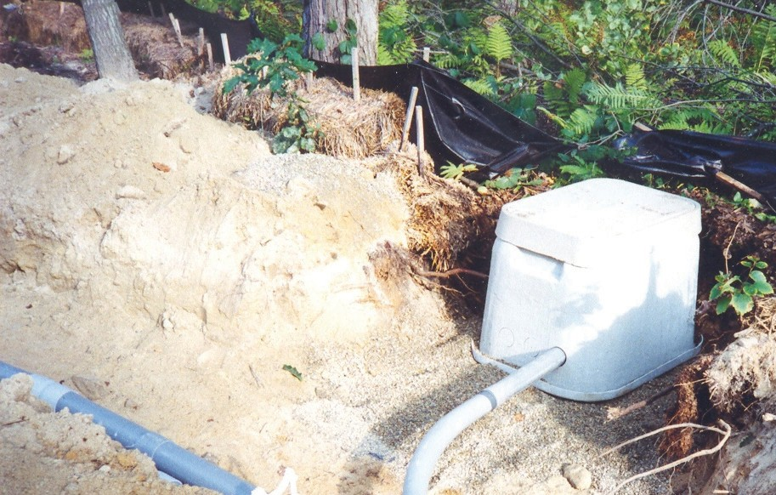
18.0-3 Proper Conduit and Handhole Installation (Pre-backfill)

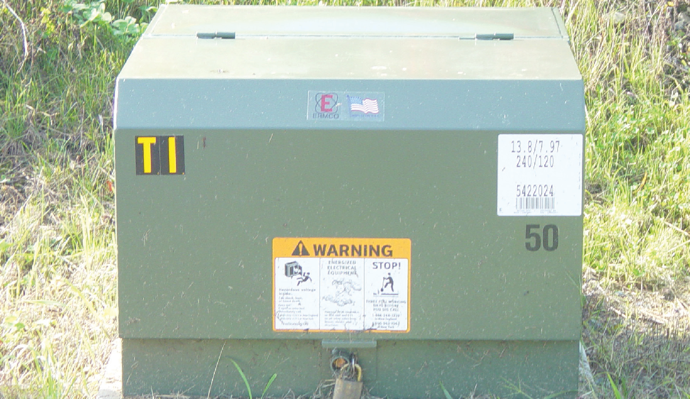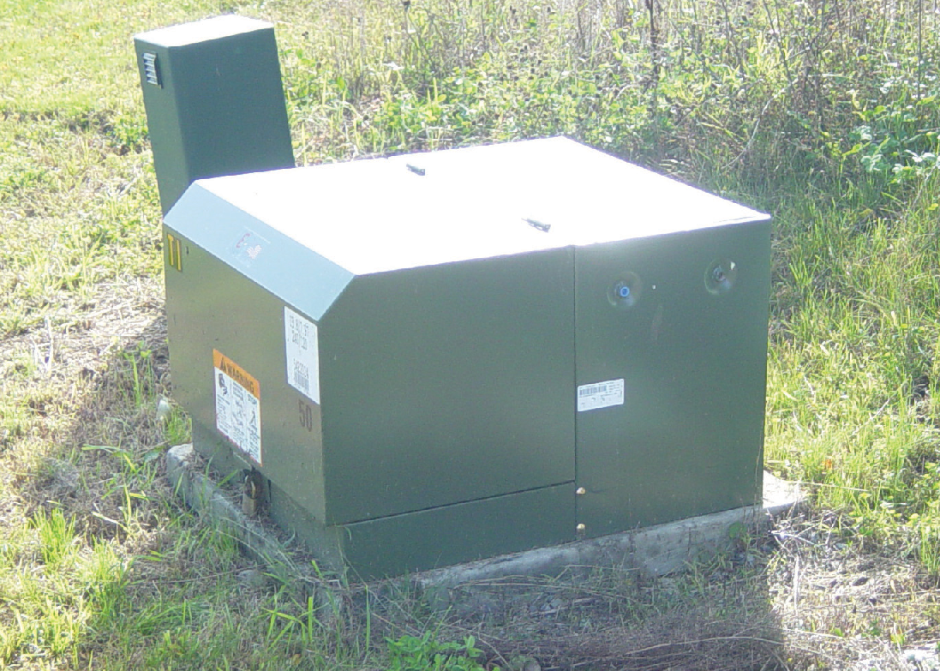
18.0-4 Properly Completed Transformer Installation (Final Grade)

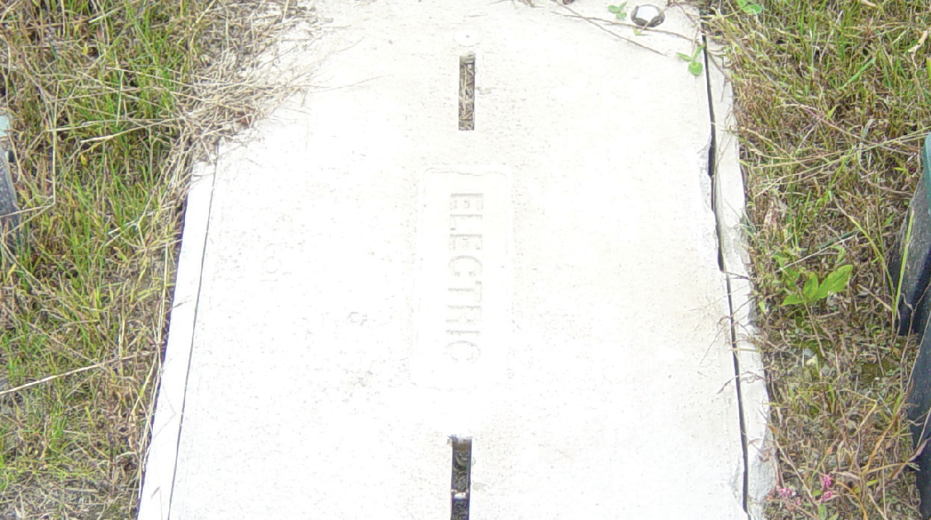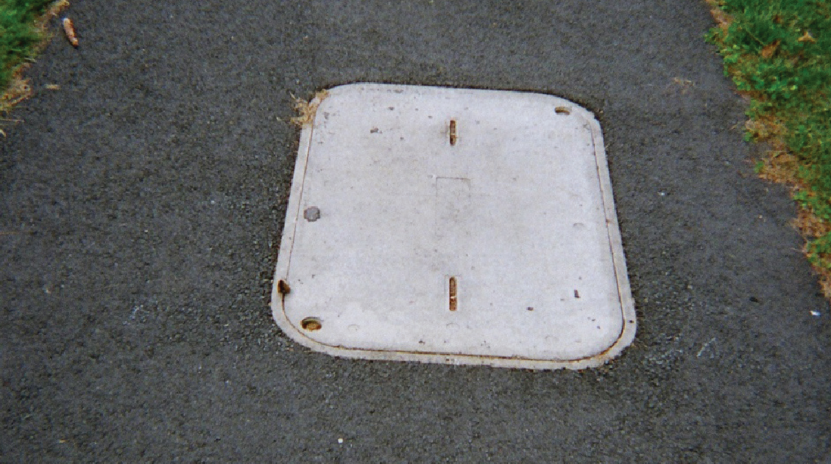 18.0-5 Properly Completed Handhole Installations (Final Grade)

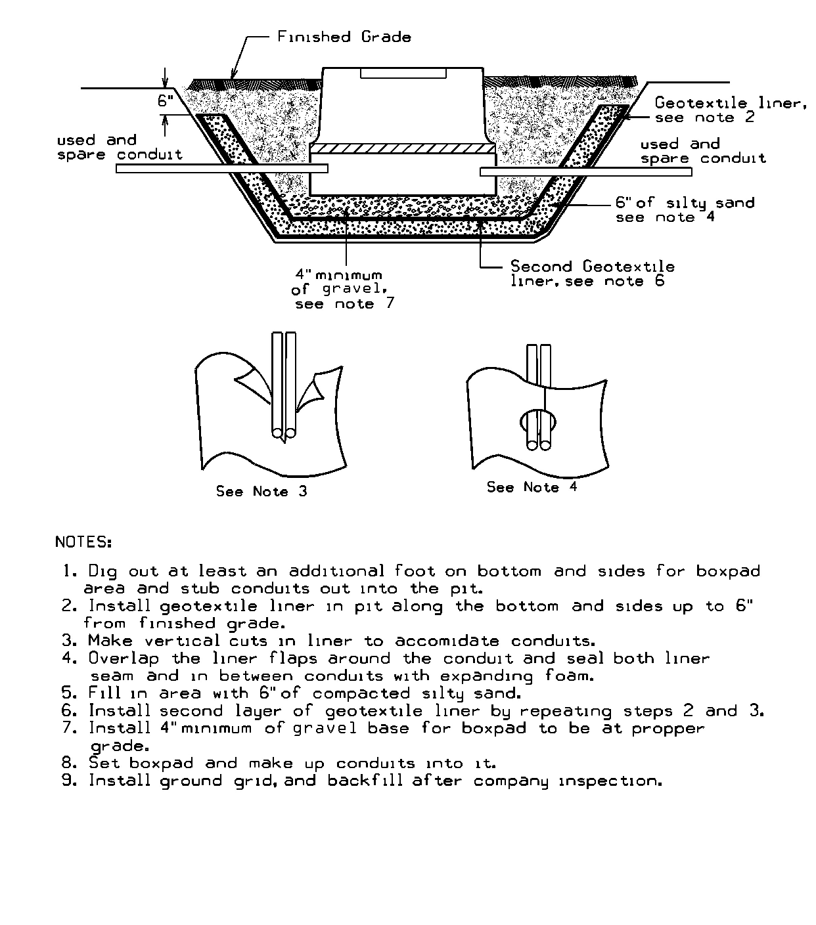

19.0 Transformer Oil Containment

Figure 19.0-1 Single Phase Oil Containment for Cables in Conduit

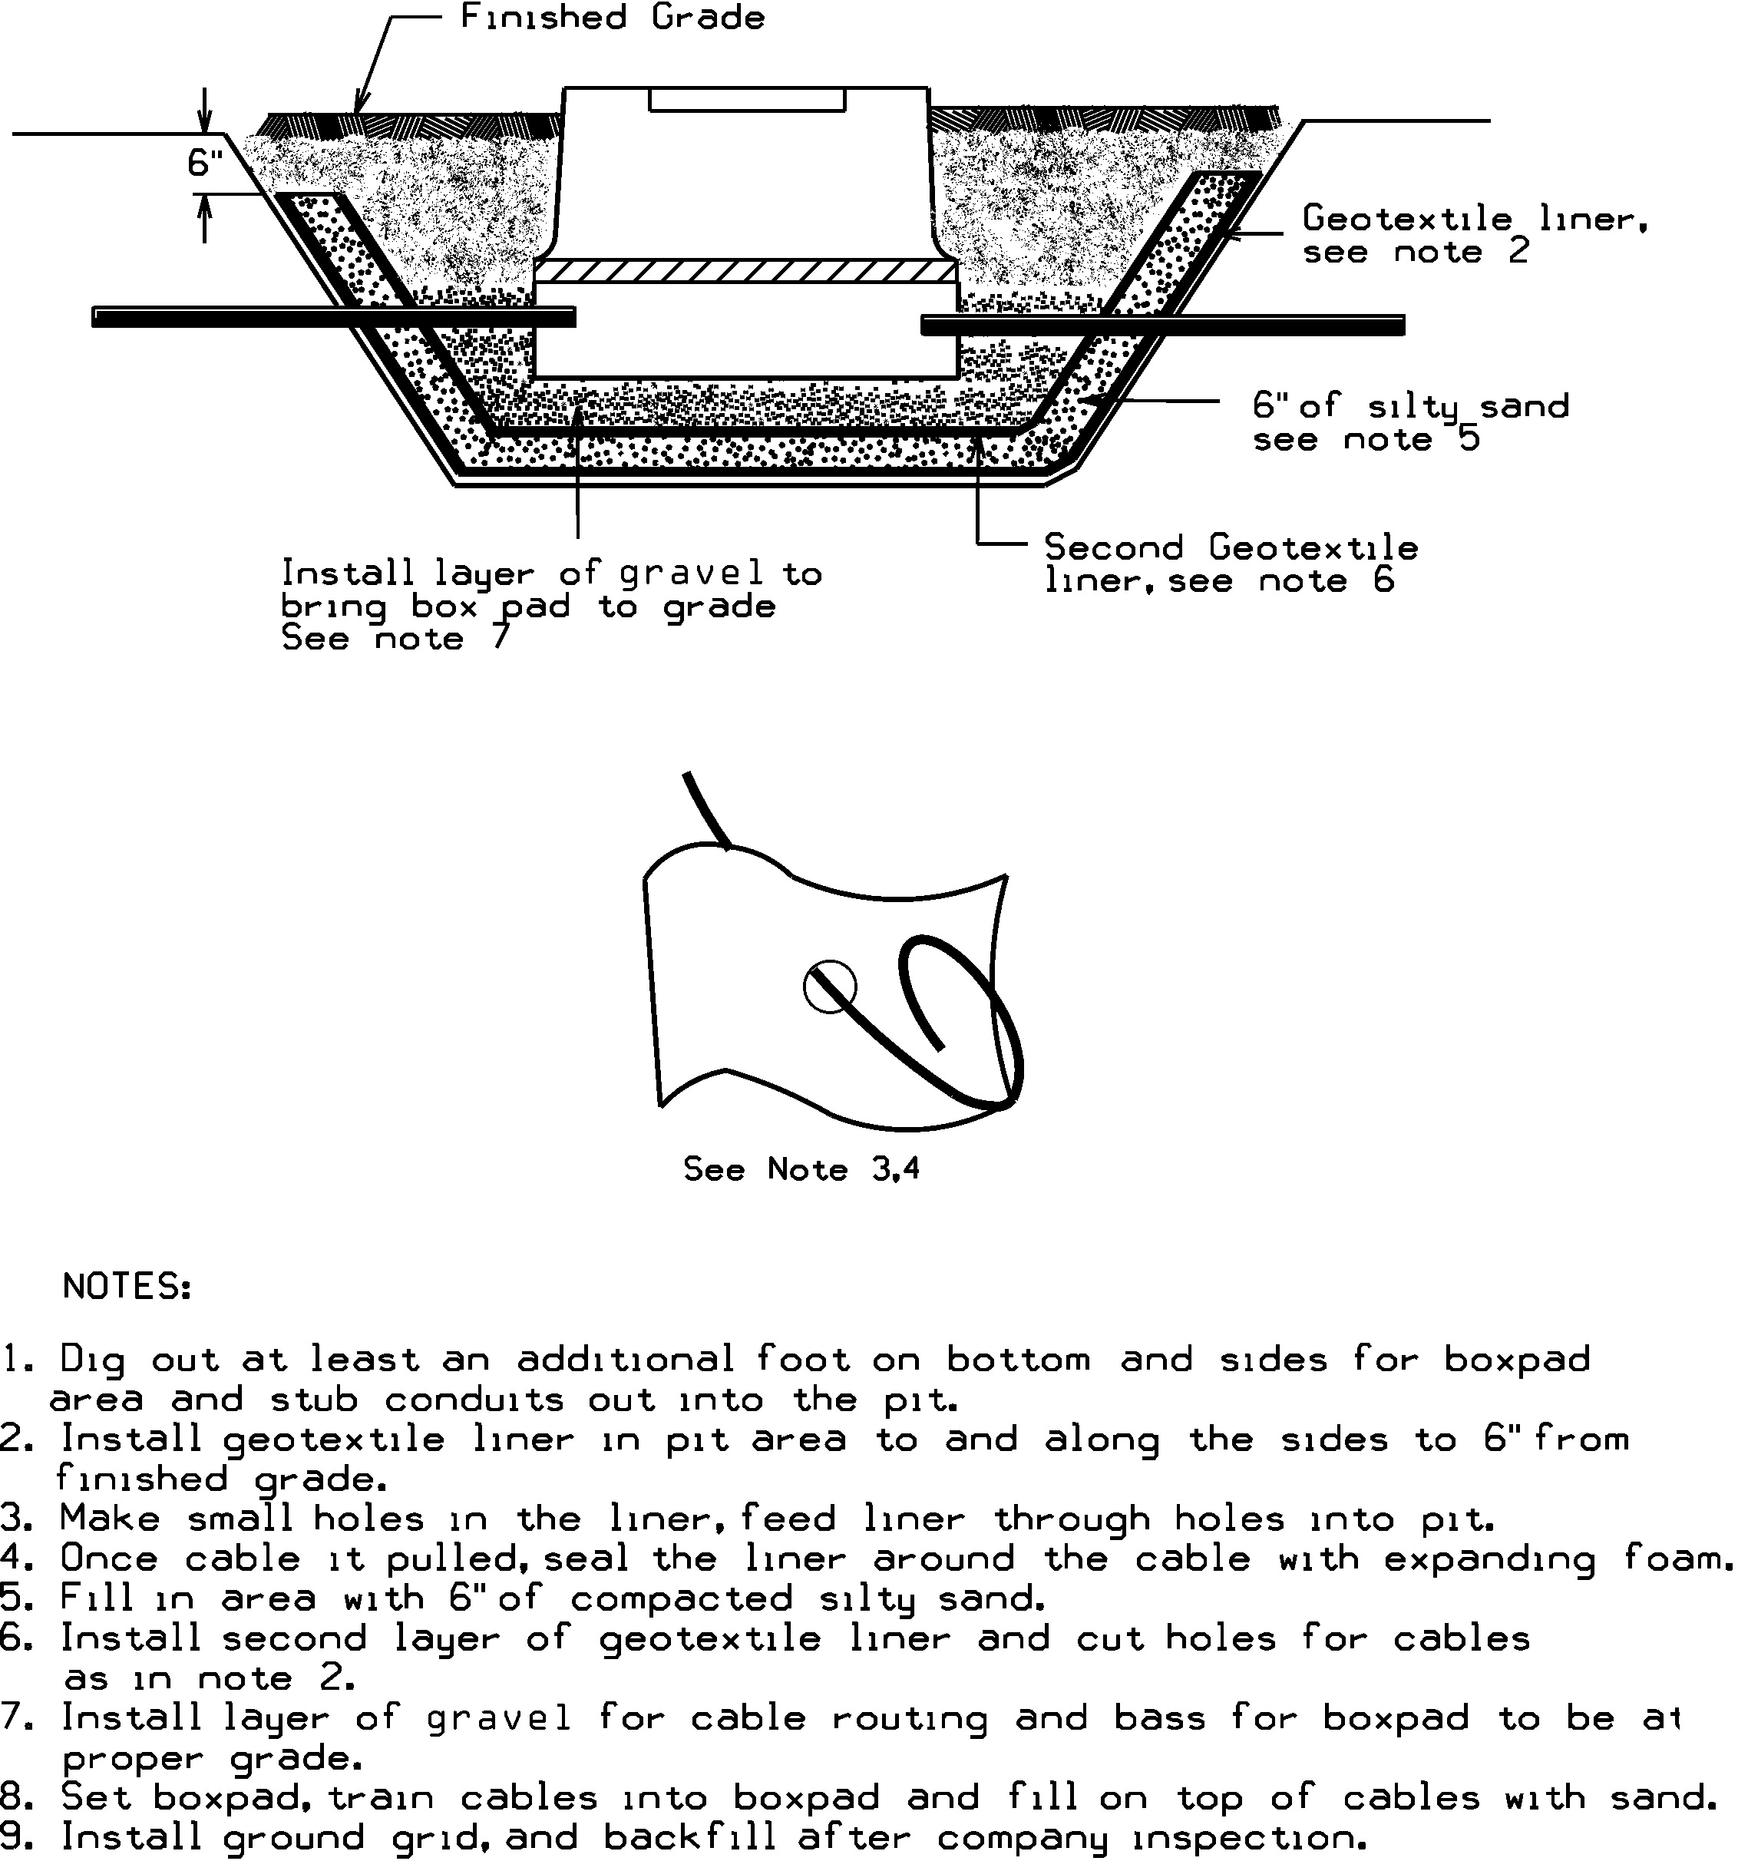 Figure 19.0-2 Single Phase Oil Containment for Direct Buried Cables

Geo-textile Liner
Generic name is: 16 oz. polypropylene geotextile. Also called filter fabric weighing 16 oz./square yard.

Brand names / Suppliers are:
AME1680 available from
American Engineering Fabrics (AEF), Inc. (Emphasize polypropylene not polyester)
New Bedford, MA
1-617-965-0007 / 1-800-770-2666 or from

Vellano Bros. Lancaster, NY 1-716-684-7222
Several other locations in New York, Massachusetts, Rhode Island and New Hampshire
www.vellano.com

Synthetic Industries ST 160 available from
Spartan Mills Inc
Spartanburg, NC 1-803-576-2353

Carthage Mills FX-160HS
US Construction Fabrics LLC
90 Range Road
Windham, NH 03087
1-603-898-0532

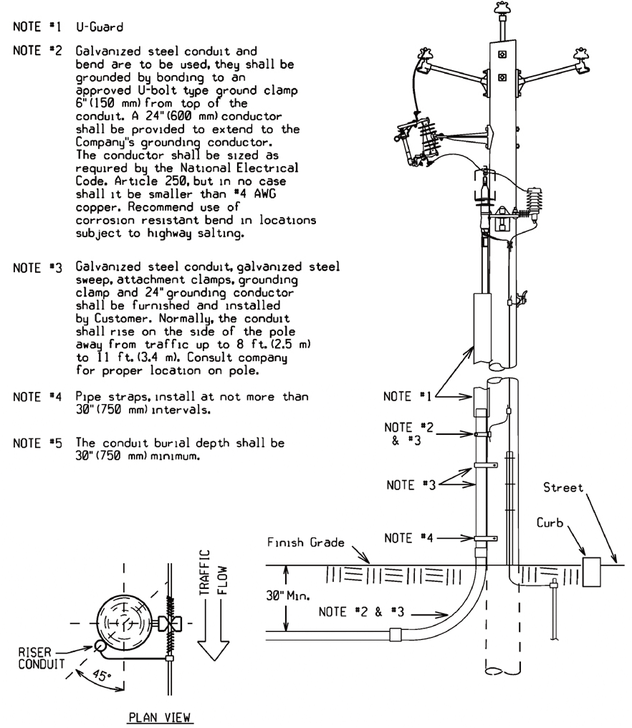

20.0 Riser Pole
The Company shall designate conduit riser locations on the pole. All primary risers shall be Galvanized Steel, this includes the 90 degree sweep. Per NESC all steel risers must be bonded 6” from top and the bond must be at least 8’ high from finished grade.
The Customer is responsible for providing and installing the bond clamps and the tap. The Company will make the bond connection from the riser bond tap to the ground system on the pole. Spare riser sweep shall be bonded also. In NewYork direct buried applications, riser sweep shall be concrete encased. Approved materials reference is located on Page 39.

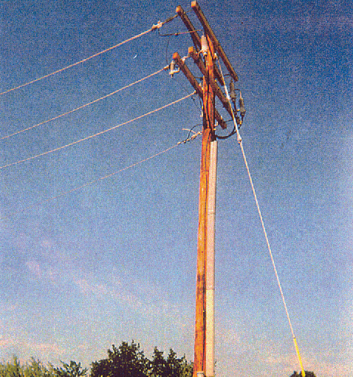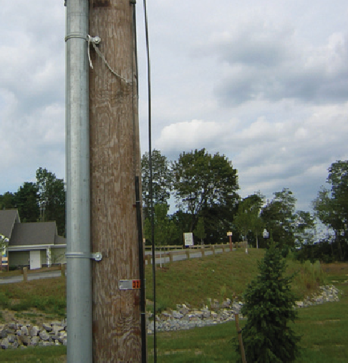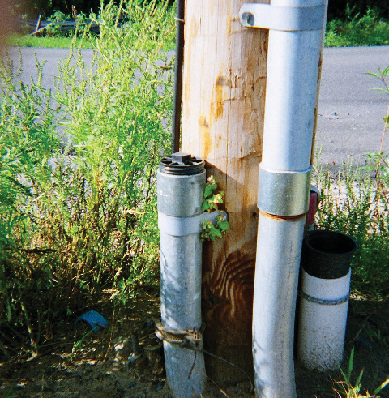
Properly Installed Primary Risers

Riser Pole Bonding
Rigid Galvanized Steel. Bond higher than 8’ and at least 6” from top.
Completed Riser Pole
The Company will specify on which quarter of the pole the riser shall be installed, away from traffic.

Spare Riser Sweep
Spare sweep shall be bonded to down ground and capped at riser pole.

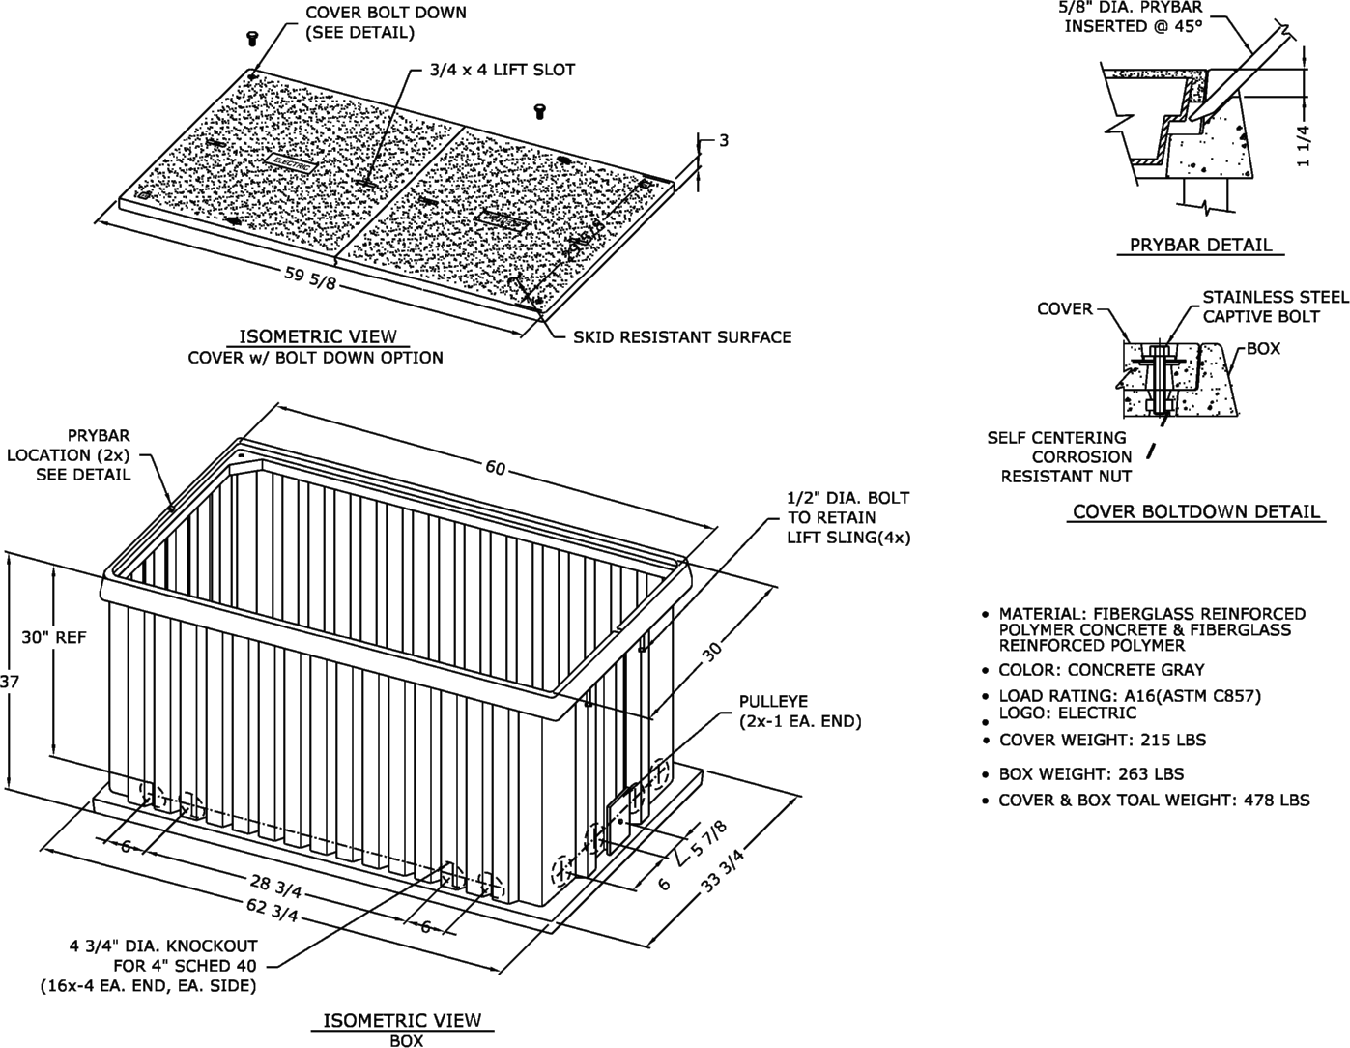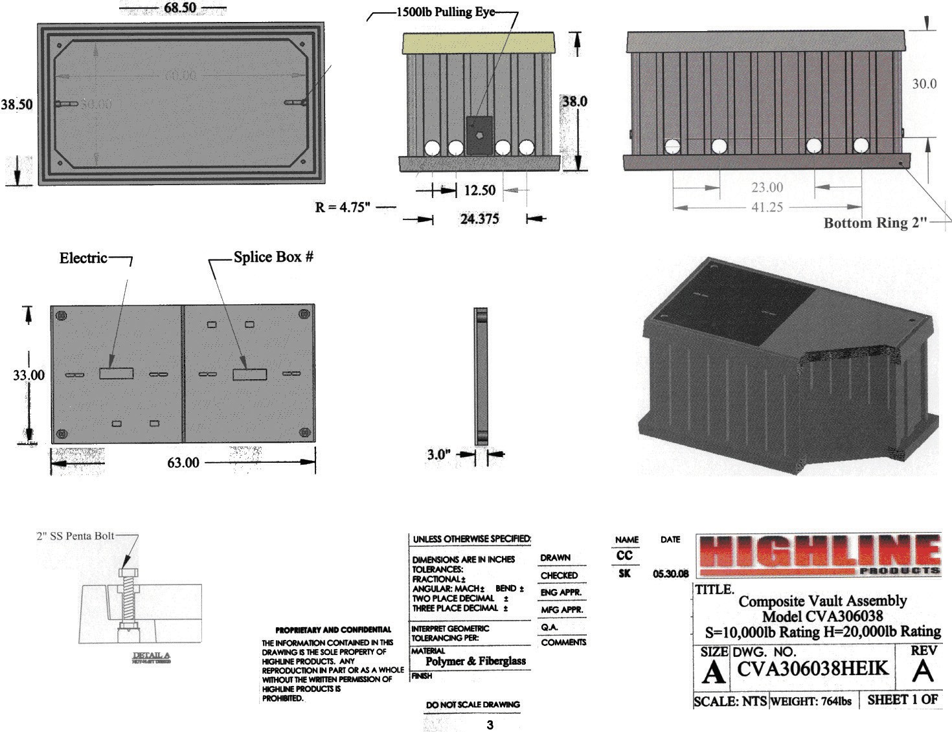

21.0 Primary Cable Pull/Splice Box
This primary conduit equipment may be specified in the design for installation in sidewalks or grass plot areas where duct length or design requires extra pulling locations or splices. The splice box is H20 rated and shall be installed in locations not frequently traveled over by vehicles. Pull/splice boxes are supplied and installed by the Customer.

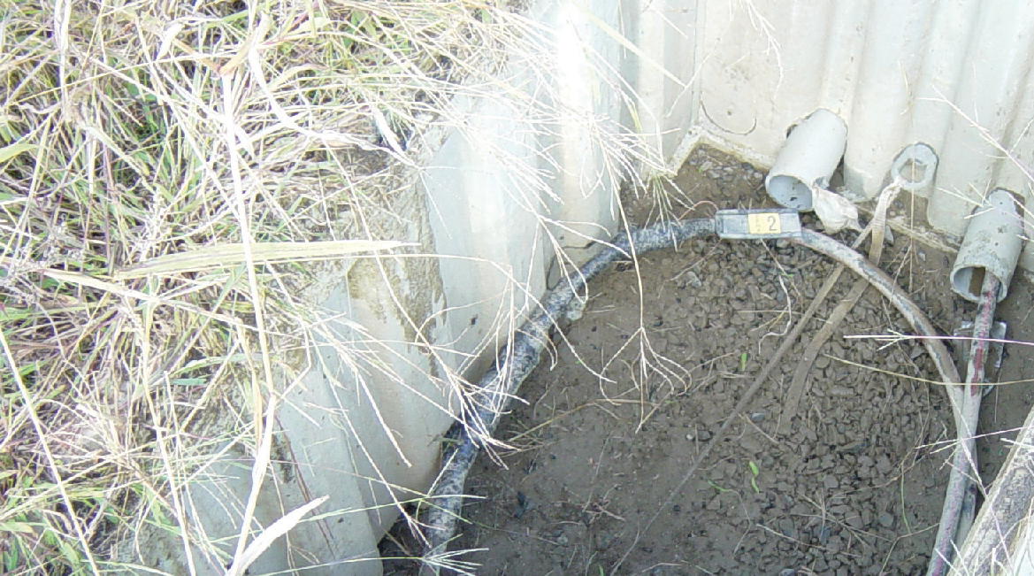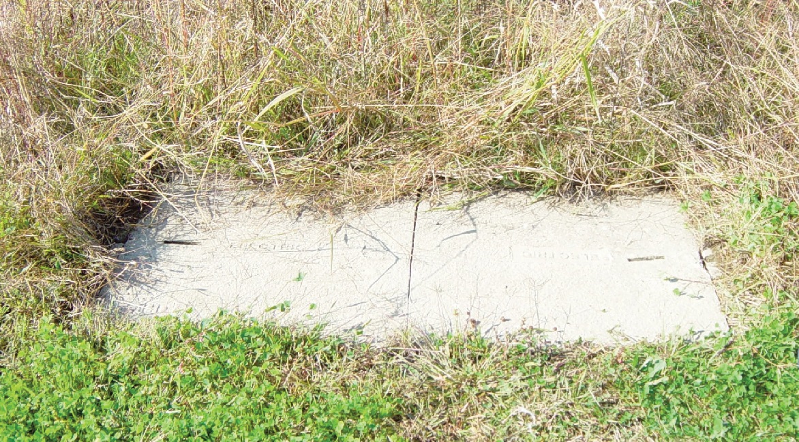
Properly Installed Primary Pullbox

22.0 Trench Requirements
Final grades shall be established, the surface rough graded within 6” of finished grade, and roadway and property boundaries shall be staked or marked by the Customer before any trenching is started.
The Customer shall adhere to the construction plan and specifications regarding trench locations, trench depth, and concrete encasement. Any deviation shall be subject to approval by the Company.
The Company shall be notified in advance of the backfilling of any electric facility. The Company reserves the right to require re-excavation of the conduits and foundations if the Customer fails to have inspection done or backfills before inspection.
For special circumstances that call for concrete encasement, such as crossing a culvert or stream, trenches shall not be backfilled until concrete has set (for at least two hours) and after approval by authorized Company personnel. All backfill shall be sand or gravel containing stones less than 1" in any dimension. Backfilling shall not take place over any open-ended (unplugged) conduits. Company approved red “Warning” tape shall be installed directly above the Company’s cable eight to 12 inches below finished grade. Laying the warning tape directly on the cable, concrete or conduit is not acceptable. Certain installations in the public way may require flowable fill instead in place of normal backfill.

Trench Depth Concrete Encased Conduit
Burial depths for electrical conduit shall be maintained not less than 30" from the top of the concrete encasement to grade during all phases of construction. The trench bottom shall be solid, undisturbed earth. Earth showing signs of peat, cinders, rubble, or any conditions not suitable for a stable foundation shall be reported to the Company for recommendation. Small pockets of unsuitable soil shall be replaced with compacted gravel (maximum 2" stone). At riser pole, end concrete encasement just before riser sweep.

Figure 22.0-1 Typical Trenches
Conduit in Concrete Trench
Conduit Trench
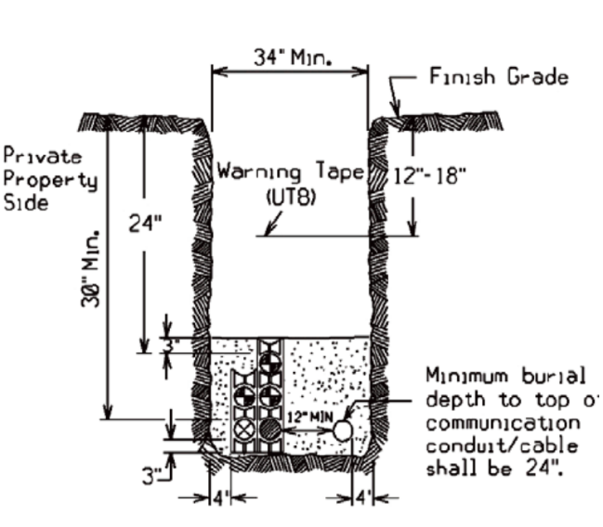
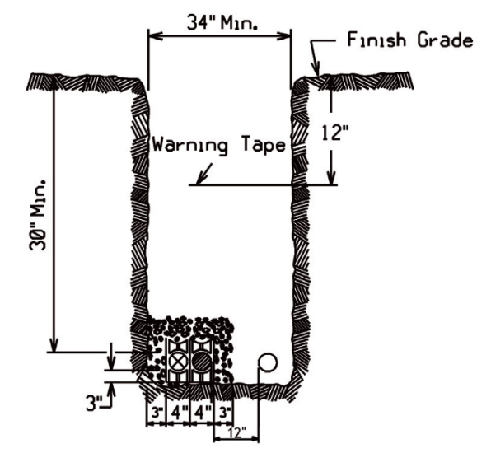

Direct Burial Trench w/RIE Gas
Direct Burial Trench
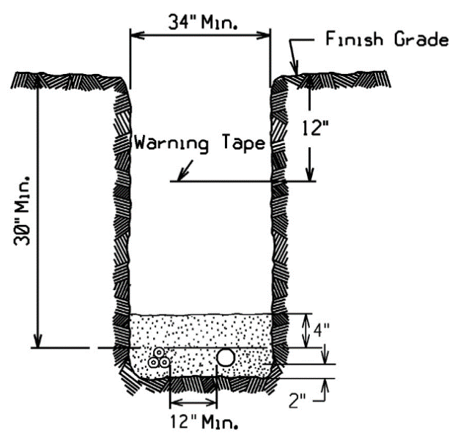
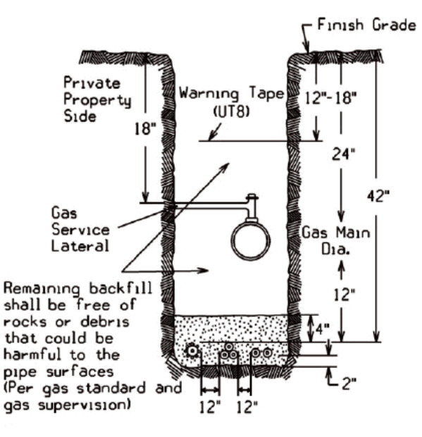

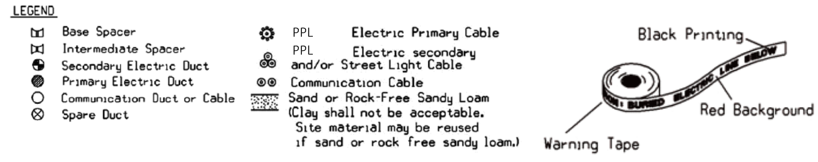

23.0 Conduit Requirements
The Customer shall be responsible for all trenching, excavation, backfilling, and installation of the primary duct system. The Customer is also responsible to supply and install any necessary pullboxes. Concrete encasement shall be provided and installed by the Customer as specified by the Company when required.
Pulling Tape
All conduits shall have a pulling tape, also known as “Mule Tape.” This tape is to be rated for 2,500 lbs. of tensile strength. Manufacturers of this tape are listed on Page 41.

Rhode Island:
The Customer shall ascertain the requirements of the specific municipality in which the development is located. For example, some municipalities may require that the Customer employ a licensed electrician to direct the installation of all conduit intended for electric facilities.
Temporary mechanical protection over buried conduit and encasements is recommended to prevent crushing or damage during construction, and is the Customer’s responsibility.
All road crossings shall, when practical, be perpendicular to the sidelines of the road.
The minimum conduit size shall be 4” for three phase and 3” for single phase cable installations. All sweeps at foundations and risers shall have a minimum radius of 36 inches. The riser sweep shall be galvanized steel. The Customer shall install conduit plugs in all unused conduits and pulling tape. At the riser pole, the galvanized rigid steel sweeps and the PVC/steel adaptors shall not be concrete encased. The Customer shall be responsible to install rigid galvanized steel straight conduit up the pole high enough to meet NESC code referenced on the riser pole requirements on Page 25, including conduit ground straps, up the riser pole (unless directed otherwise by the Company). The Company will specify on which quarter of the pole the riser shall be installed, usually away from oncoming traffic.
Except as noted on construction prints, curves and bends in conduit shall be gradual, and the radius of curvature shall not be less than 40 feet. All curves shall be formed with five-degree couplings. The minimum length between single, five-degree couplings is 42".
Conduit grade shall be such as to cause all ducts to drain toward one or both equipment foundations or pullboxes. Minimum pitch shall be three inches per 100 feet.
The Customer shall insure that clearances are met and maintained, and that they are inspected by the Company. Unless local jurisdictions require greater clearances, the minimum clearances shall be as follows:

Communication Systems – Company conduit shall not be directly above or below communication conduit, except when crossing below communication conduit at approximately right angles. Company conduit and communication conduit shall be separated by a minimum of 3" of concrete encasement.

Non-Company Water, Gas and Sewer – Company conduit shall not be directly above or below any of these foreign utilities, except when crossing above these utilities at approximately right angles. Where the paths of these foreign utilities cross under Company conduits at approximately right angles, the minimum separation is 12". A minimum separation of 24"
shall be maintained between parallel placement of any of these utilities and electrical conduit.
A six-inch clearance shall be between conduit envelopes and major subsurface pipes (e.g. drainage pipes).
The Customer shall rod and mandrel all primary conduits to insure their integrity before the Company shall attempt to pull any primary cable. The Customer shall furnish and install an approved synthetic, 2,500 pound test tape in each primary conduit run including risers.
Pulling tape installation and rodding the duct shall be witnessed by the Company.
Company-owned duct shall not share a concrete encasement with foreign utilities (e.g. do not place communication or private electrical duct in the same concrete encasement as Company duct).
At those locations where manholes or above ground switchgear are required, additional specifications will be provided by the Company.

24.0 Metering
Refer to the Company’s Specification for Electrical Installations book for the type of installation. Division of work and material will be performed with the approval and authorization of the Company’s Metering Services department.

25.0 Easement Applications

RHODE ISLAND EASEMENT APPLICATION FORM
FOR COMPANY USE ONLY

Application for Easements (check one): ❒ OH (jointly owned or solely owned) ❒ UG ❒ Electric
❒ Padmount transformer only ❒ URD ❒ Gas
Work Request Number
Utility Engineer’s Name: Telephone Number:

Please complete ALL of the sections below so that we may prepare an easement for your signature. Do not leave any sections unanswered. If a section does not apply to you simply put “n/a” on that line. Incorrect or incomplete information will delay service installation.
Property Owner(s):

Property Owner Mailing Address Property Address of Easement
(if different from mailing address)

Address:
City:
State & County
Zip
Address:
City:
State & County
Zip
Customer Contact Person:
Daytime Phone(s): Re: Subdivision Title:

- Provide us with a RECORDED copy of the present owner’s deed, Book Page
  - If multiple deeds make up the whole parcel, please include all deeds.

  - If the Property Owner is a b1) CORPORATION, b2) TRUST, b3) PARTNERSHIP, or b4) LIMITED LIABILITY COMPANY, provide the following which is applicable:

b1) President Name: Treasurer Name:
See Footnote1 Below
Or
Vice President: Asst. Treasurer:

1 If neither “Name Combinations” is available, the person(s) signing the easement must have a Corporate vote authorizing them to sign on behalf of the Corporation.

b2) Trust: No. Of Trustees: Name(s): Name of Trust: b3) Partnership: Number of Partners: Name(s): b4) LLC: Authorization to Sign, Name(s):
- a) Provide us with an approved: “Definitive Subdivision Plan”
Plan Book: Plan: Dated:
b) If there is no recorded subdivision plan please include the following information:
Assessor’s Map: Block: and Lot:
- Is your property mortgaged (circle one)? YES NO If “YES”, please complete this section:
  - Name of Bank/Company/Person holding mortgage(s):
  - Address of mortgage holder(s):
  - Date and recording information of mortgage(s): Date: County Recorded: Book: Page:

Additional Comments:
________________________________________________________________________________________________________________________________________________________________________________________________________________________________________________________________________________________________________________________________________________________________________________________________________________________________________________________________________________________________________________________________________________________________________________________________________________________________________________________________________________________________________________________________________________________________________________________________________________________________________________________________________________________________________________________________________________________________________________________________________________________________________________________________________________________________________________________________________________________________________________________________________________________________________________________________________________________________________________________________________________________________________________________________________________________________________________________________________________________________________________________________________________________________________________________________________________________________________________________________________________________________________________________________________________________________________________________________________________________________________________________________________

Please contact your Account Manager or Service Administrator if you have any questions regarding this for

26.0 Approved Material – Underground Residential Installations

Item ID | Item Description | Manufacturer 1 Part Number | Manufacturer 2 Part Number | Manufacturer 3 Part Number
Conduit—Straight

2010404 | Conduit, 4", PVC | Carlon: 48815 | IPEX: 8741 | Cantex: A79EA42
2011024 | Conduit, Galvanized, 4" | By Description
5692158 | Conduit, 3", PVC | Carlon: 48815 | IPEX: 08731 | AMERICAN PIPE TC7215752
5692107 | Conduit, Galvanized, 3" | BAYNEJONES 300R
Conduit—Blends

5690446 | Bend, Galvanized, 4" 36” | BaynesJones 400R9036 | Conditmfg  TUB490D36RGA LEL
5690493 | Bend, PVC Sch 40, 4",  90 Degree, 36" Rad. | Carlon: UA9FNB | Cantex: 5233842
5690436 | Bend, Galvanized, 3" 36” | BaynesJones 400R9036 | Conditmfg TUB490D36RGA LEL
5690419 | Bend, PVC DB, 3",  90 Degree, 36" Rad. | Carlon: PF9FL | Cantex: 5123872 | Certisaft 59734
Spacers

5646963 | Spacer, 4", Base | GS Industries: 186-1 | IPEX: 29573
5646960 | Spacer, 4", Inter. | GS Industries: 185-1 | IPEX: 29557
5646958 | Spacer, 3", Base | GS Industries: 157-1 | IPEX: 29569
5646956 | Spacer, 3", Inter. | GS Industries: 156-1 | IPEX: 29553

Item ID | Item Description | Manufacturer 1 Part Number | Manufacturer 2 Part Number | Manufacturer 3 Part Number
Conduit Accessories

5641210 | Riser Strap, 4" | Electrical Materials: 50-4 USHD | BaynesJones MINRLAC HD-296
5641205 | Riser Strap, 3" | Electrical Materials: 50-3 USHD | BaynesJones MINRLAC HD-294
7011830 | Lag Screw, 1/4" x 2" | Elect. Materials: 106 or 106M | Joslyn J26486.1 | PLH LSNW-142
3503074 | Pipe Grd. Connector, 4" and 5" | T & B: (0)3905-BU | Burndy GAR3905-BU
3503075 | Pipe Grd. Connector, 2.5" and 3.5" | T & B: (O)3904-BU | Burndy: GAR3904-BU
2010424 | Duct Plug, 4" DB | Carlon: P258NT | GAR3905-BU
5645682 | Duct Plug, 3" DB | CANTEX : 5315260 | CARLON: P258L | CERTIFSAFT: 59653
2011254 | Duct Plug Galvanized 4” | Crousehind PLG105
9201659 | Duct Plug Galvanized 3”
2010434 | Adapter, Female, PVC-Steel, 4" | Carlon: E942N | Cantex: 5140052 | Scepter FA55
2010433 | Adapter, Female, PVC-Steel, 3" | Carlon: E942N | OZGEDNEY: PLG-300C
5693359 | Coupling, 5 Degree,  Bell-Spigot, 4" | Carlon: E244N | Cantex: 6151452 | Certisaft 59544
5693356 | Coupling, 5 Degree,  Bell-Spigot, 3" | Cantex: 6151450 | Carlon: E244L
2010444 | Coupling, 5 Degree,  Bell-Bell, 4" | Ameripipe: FT518 | Carlon E2440NF | Scepter 7604360040

Item ID | Item Description | Manufacturer 1 Part Number | Manufacturer 2 Part Number | Manufacturer 3 Part Number

5100696 | Coupling, 5 Degree,  Bell-Bell, 3" | Ameripipe: NS141 | Carlon 6151458
2010454 | Straight Coupling, 4", EB/DB | Carlon: E240N | Cantex: 6151450
2010453 | Straight Coupling, 3", EB/DB | Cantex: 6151450 | CARLON : E2544L
Grounding Accessories

961285 | Grounding Bushing, 4" and 5” | Burndy GAR3905-BU | T&B: (0)3905-BU
3500313 | Grounding Rod 5/8’ x 8’ Solid Copperweld | Galvin 6258 | ERITECH 615880 | Joslyn: J8338
4015032 | #2 AWG, 7 strand, soft drawn | South Wire - By description
3503328 | Ground Rod Clamp | Burndy: GRC58 | Blackburn: JAB58H | Electromotion EM58DBW
5960412 | “C” Connector, 2/0 – 2/0 | Burndy: YC26C26TN
Primary Pullbox Secondary Handholes

5640808 | Primary Pull/Splice Box | CDRSYSTEM: PA12-3060-37 | Highline: CVA306038HEIK
5643082 | Handhole (for conduit) | Highline: PA10- 1730-30-0319 | Highline: CHA173030SE1-NG | NORDICFIB:  GS-37-23-30-NEPS
0810696 | 2" extension ring for item #0810696 | Carson: 1324PR-100

Other Materials

 | Secondary Connections | Burndy | Richards
 | Pulling Tape | Arnco: DLWP25 | Condux: 08096303 | Neptco: WP2500P

27.0 Job Checklists

URD CONDUIT INSPECTION CHECKLIST
Do not back fill BEFORE conduit system inspection and approval by the Company have been obtained. Every item below must be inspected and checked off by the Company representative. Any item found unacceptable must be initialed and rectified by Customer by next inspection.

N* | Y* | PRE-TRENCH
❒ | ❒ | Final Grade established
❒ | ❒ | Surface rough graded
❒ | ❒ | Roadways staked
❒ | ❒ | TRENCH  Minimum 30” depth from finishing grade to top of primary conduit
❒ | ❒ | Minimum 24” depth from finishing grade to top of secondary conduit
❒ | ❒ | Minimum 12”separation between Electric conduits and Telecommunications conduits
❒ | ❒ | Min, 24” separation between Electric conduits and water, sewer or gas if placing parallel
❒ | ❒ | Minimum 12” separation between Electric conduits and water, sewer or gas if placing perpendicular
❒ | ❒ | Conduit plugs installed
❒ | ❒ | Plastic spacers properly installed no more than every 8’ and at every junction point
❒ | ❒ | 4” screened backfill (with less than 1” stones) on-site for backfilling entire trench,
❒ | ❒ | (inspector may witness backfilling)  Warning tape installed 12” below finish grade and directly above electrical conduit system
❒ | ❒ | All curves properly formed with five degree couplings
❒ | ❒ | No parallel utilities directly above electrical system
❒ | ❒ | Secondary Handhole  4” crushed stone under handhole
❒ | ❒ | Handhole covers installed and properly secured with pentahead bolts
❒ | ❒ | Top surface flush with final grade
❒ | ❒ | Conduit plugs installed from the outside in all unused conduit knockouts
❒ | ❒ | No more than 3” of extended PVC into handhole
❒ | ❒ | Transformer Foundation  4”of crushed stone under transformer foundation
❒ | ❒ | Top surface 4” above final grade
❒ | ❒ | No more than 3” extended PVC through foundation
❒ | ❒ | Pulling eyes properly installed in front and back of box pad (ring part on the inside)
❒ | ❒ | Conduit plugs installed from the outside in all unused conduit knockouts
❒ | ❒ | Two ground rods installed at opposite corners of foundation – exposed for inspection
❒ | ❒ | Ground grid buried 12" below finish grade and placed 12" away from edge of boxpad
❒ | ❒ | Loop ground grid around and into foundation through two sides of foundation
❒ | ❒ | Correct orientation to road and lot lines
❒ | ❒ | All non-Company owned pedestals are a minimum of 2’ away from all sides
 |  | Pullbox
❒ | ❒ | 4” or crushed stone under pullbox foundation
❒ | ❒ | Pullbox covers installed and properly secured with pentahead bolts
❒ | ❒ | Top surface flush with final grade
❒ | ❒ | No more than 3” extended PVC into pullbox
❒ | ❒ | Conduit plugs installed from the outside in all unused conduit knockouts
❒ | ❒ | All non-Company owned pedestals are a minimum of 2’ away from all sides
 |  | RISER POLE
❒ | ❒ | 90° bend and 10’ straight riser pipe galvanized steel conduit. (3” for single Phase, 4” for three phase)
❒ | ❒ | Steel-PVC adapter and steel sweep shall not be encased in concrete
❒ | ❒ | Ground clamp installed with tap
❒ | ❒ | Install 2500 lb. Pulling Tape in all conduit after rodding with mandrell

*NOTE Y – Acceptable N – Deficient

