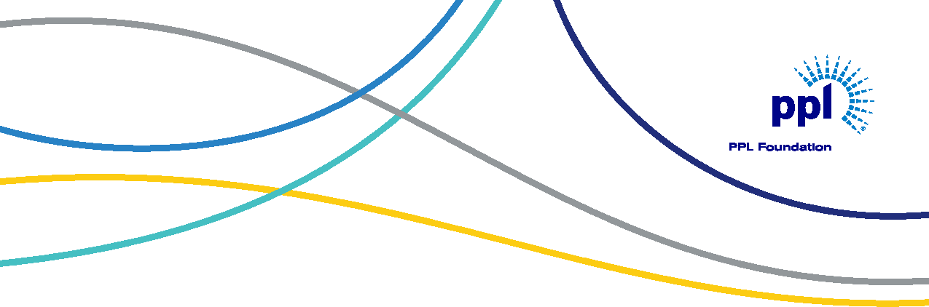
Empowering Communities Grants Application
(continued)
Funded by the PPL Foundation, Empowering Communities Grants aim to empower Rhode Island communities by supporting student success from cradle to career; advancing diversity, equity and inclusion; and promoting
the development of vibrant and sustainable communities.
Organization Name:
Organization Address:
Organization Website:
Organization EIN:
Applicant Name:
Applicant Title:
Applicant Email:
Applicant Phone:
Program Title:
Requested Funding:
Desired Results
What are the desired results of this program? Limit 1000 words
Targets and Milestones
Specify the performance targets and critical milestones you must achieve to reach the desired results. Limit 1000 words

Measurement of Success
(continued)
Describe how you will track and measure success of the program. Limit 1000 words
Program Alignment
How is your program aligned with PPL Foundation’s priority areas of education; diversity, equity and inclusion; or sustainable communities?
Limit 1000 words
People Served
Define the number and characteristics of the people your program will serve. Limit 5000 words
Staff Expertise
Describe the expertise of the key staff working to develop and implement this program. Limit 500 words
Budget Narrative
Please provide a budget summary of this program, describing how this program fits in the overall organization budget and outlining major expenditures, additional revenue sources and the role this grant would play for this program. Limit 500 words

Program Continuity
How will your program continue without investment from this source? Limit 500 words
Program Promotion Efforts
Describe how you will promote this program and our support (if a grant is received). Limit 500 words
Required Documentation:
Please include the following documentation with your application
- Budget – project and full organization budget
- W-9
Questions and/or completed applications should be sent via email to Community@rienergy.com.

